Doküman No | UNİKA -FRM-0274
Yayın Tarihi | 02.10.2023
Revizyon Tarihi | -
Revizyon No | 0
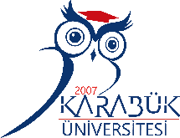

KARABUK UNIVERSITY
LETTER OF INVITATION

We hereby confirm that Karabuk University invites (STAFF NAME) from (UNIVERSITY NAME, COUNTRY) within the scope of Erasmus+ Staff Training Mobility Program from (…) till (...)

Date

Lect. Oya ÖNALAN
International Relations Coordinator

Karabuk University, International Relations Office, Rektörlük Binası C Blok 3. Kat Kılavuzlar Köyü Öte Karşı Üniversite Kampüsü 78050 Karabuk / TURKİYE
Tel:+90 370 418 8049 Fax:+90 370 418 94 07 e-mail: erasmus@karabuk.edu.tr

